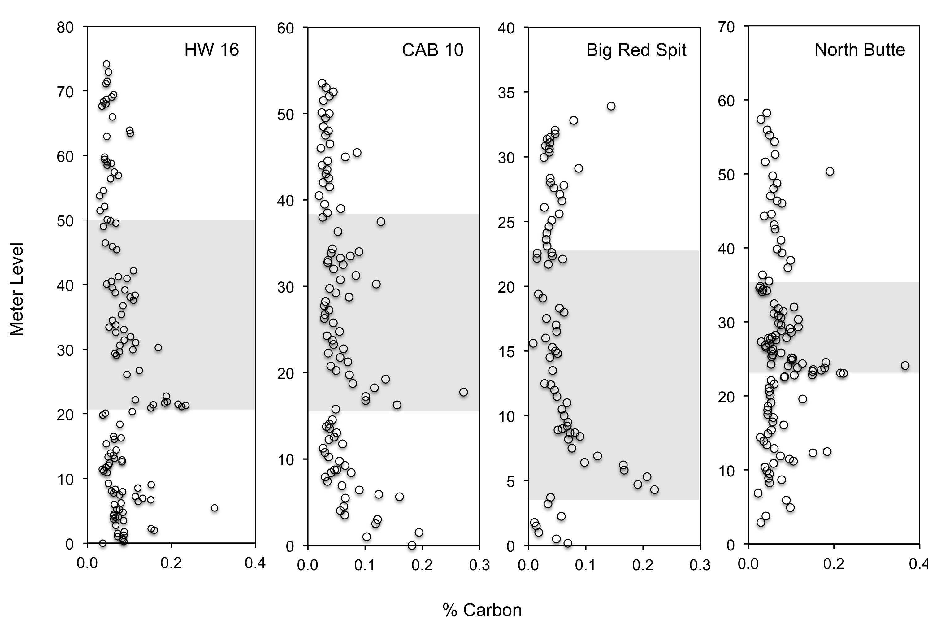
Supplemental Figure 1. Percent carbon through the Bighorn Basin PETM sections published by Baczynski et al. (2013). The gray shaded areas highlight the PETM interval.

Sample | Meter Level Correlated to Bowen & Bowen (2008) | δ¹³C_{org} | St. Dev. | %C | δ¹³C_{cc} (Bowen & Bowen 2008) | Δ¹³C | Δ¹³C Anomaly
AX-12-35 | 25.55 | -23.34 | 0.30 | 0.14 | -5.9 | 17.44 | -0.44
AX-12-36 | 28.55 | -23.32 | 0.28 | 0.12 | -5.45 | 17.87 | -0.01
AX-12-46 | 76.03 | -23.08 | 0.47 | 0.04 | -5 | 18.08 | 0.20
AX-12-47-5 | 77.52 | -23.14 | 0.42 | 0.02 | -4.95 | 18.19 | 0.31
AX-12-47-4 | 77.62 | -23.08 | 0.47 | 0.03 | -4.95 | 18.13 | 0.25
AX-12-47-3 | 77.73 | -22.84 | 0.74 | 0.03 | -4.95 | 17.89 | 0.01
AX-12-47-1 | 77.99 | -23.50 | 0.23 | 0.03 | -4.95 | 18.55 | 0.67
AX-12-03 | 93.92 | -24.40 | 0.14 | 0.10 | -6.15 | 18.25 | 0.37
AX-12-49 | 94.50 | -23.82 | 0.21 | 0.05 | -6.15 | 17.67 | -0.21
AX-12-24 | 97.88 | -23.89 | 0.08 | 0.06 | -5.9 | 17.99 | 0.11
AX-12-50 | 104.04 | -26.11 | 0.18 | 0.04 | -9.05 | 17.06 | -0.82
AX-12-05 | 104.39 | -24.61 | 0.19 | 0.06 | -9.1 | 15.51 | -2.37
AX-12-26 | 104.86 | -24.99 | 0.08 | 0.06 | -9.1 | 15.89 | -1.99
AX-12-06 | 108.41 | -25.80 | 0.16 | 0.03 | -8.3 | 17.50 | -0.38
AX-12-07 | 108.83 | -26.19 | 0.12 | 0.04 | -8.3 | 17.89 | 0.01
AX-12-08 | 109.31 | -24.84 | 0.23 | 0.05 | -8.3 | 16.54 | -1.34
AX-12-27 | 112.06 | -23.87 | 0.57 | 0.19 | -7.4 | 16.47 | -1.41
AX-12-10 | 116.29 | -23.79 | 0.44 | 0.10 | -6.4 | 17.39 | -0.49
AX-12-14 | 116.70 | -24.56 | 0.13 | 0.09 | -6.4 | 18.16 | 0.28
AX-12-11 | 117.34 | -23.49 | 0.35 | 0.12 | -6.4 | 17.09 | -0.79
AX-12-52 | 117.40 | -23.54 | 0.31 | 0.11 | -6.4 | 17.14 | -0.74
AX-12-15 | 118.35 | -26.21 | 0.17 | 0.04 | -5.85 | 20.36 | 2.48
AX-12-51 | 118.93 | -22.78 | 0.36 | 0.16 | -5.85 | 16.93 | -0.95
AX-12-12 | 119.51 | -23.29 | 0.15 | 0.10 | -5.1 | 18.19 | 0.31
AX-12-29 | 121.10 | -23.04 | 0.37 | 0.11 | -5.5 | 17.54 | -0.34
AX-12-30 | 126.02 | -23.00 | 0.41 | 0.08 | -6 | 17.00 | -0.88
AX-12-53 | 127.44 | -23.26 | 0.45 | 0.13 | -5.95 | 17.31 | -0.57
AX-12-16 | 130.35 | -24.35 | 0.24 | 0.04 | -6 | 18.35 | 0.47
AX-12-17 | 130.65 | -24.17 | 0.18 | 0.04 | -6 | 18.17 | 0.29
AX-12-19 | 136.33 | -23.50 | 0.43 | 0.13 | -6.1 | 17.40 | -0.48
AX-12-21 | 147.12 | -24.32 | 0.14 | 0.10 | -6.15 | 18.17 | 0.29

Supplemental Table 1. Isotopic compositions of preserved organic material and pedogenic carbonates from paleosols at Axhandle Canyon, Utah. The δ¹³C_{org} measurements are new and were analyzed at the University of Michigan Stable Isotope Laboratory for this study. The δ¹³C_{cc} measurements were previously published by Bowen and Bowen (2008). The black line outlines the data that has been identified as the PETM.

Meter Level | δ¹³C_{org} (Magioncalda et al. 2004) | δ¹³C_{cc} (Bowen et al. 2001) | Δ¹³C | Δ¹³C Anomaly
1479.90 | -23.44 | -9.10 | 14.34 | -1.28
1480.15 | -23.17 | -9.10 | 14.07 | -1.42
1480.60 | -23.56 | -9.10 | 14.46 | -1.33
1480.60 | -23.75 | -9.10 | 14.65 | -1.23
1483.31 | -23.27 | -9.40 | 13.87 | -1.36
1483.81 | -23.68 | -9.40 | 14.28 | -1.55
1484.18 | -23.49 | -9.40 | 14.09 | -1.54
1485.00 | -24.82 | -10.93 | 13.90 | -1.63
1485.70 | -23.60 | -10.93 | 12.68 | -2.34
1485.75 | -23.08 | -10.93 | 12.16 | -2.71
1485.95 | -24.01 | -10.93 | 13.09 | -2.98
1486.06 | -23.91 | -10.93 | 12.99 | -2.88
1486.21 | -24.00 | -10.93 | 13.08 | -2.57
1495.20 | -25.75 | -9.68 | 16.07 | 0.45
1495.40 | -26.23 | -9.43 | 16.81 | 0.82
1495.59 | -24.45 | -9.43 | 15.03 | 0.35
1496.80 | -24.72 | -9.43 | 15.30 | 0.09
1498.66 | -24.61 | -9.88 | 14.74 | -0.60
1499.22 | -24.48 | -10.60 | 13.88 | -0.98
1500.62 | -25.16 | -10.20 | 14.96 | -1.10
1501.23 | -24.35 | -12.40 | 11.95 | -2.02
1502.02 | -24.63 | -12.50 | 12.13 | -2.61
1502.86 | -24.31 | -12.50 | 11.81 | -3.66
1504.11 | -26.22 | -13.30 | 12.92 | -3.33
1505.00 | -25.01 | -13.30 | 11.71 | -3.47
1505.13 | -25.37 | -13.30 | 12.07 | -3.39
1505.50 | -25.37 | -13.30 | 12.07 | -3.67
1506.69 | -26.86 | -13.88 | 12.99 | -3.25
1507.00 | -28.00 | -14.38 | 13.63 | -2.73
1507.44 | -27.42 | -14.28 | 13.15 | -2.37
1507.81 | -27.24 | -15.50 | 11.74 | -2.78
1510.35 | -27.69 | -13.95 | 13.74 | -2.75
1510.50 | -27.83 | -13.95 | 13.88 | -2.50
1511.29 | -26.90 | -14.60 | 12.30 | -2.31
1512.22 | -26.70 | -14.96 | 11.74 | -2.98
1514.35 | -25.88 | -14.75 | 11.13 | -3.90
1515.00 | -27.44 | -13.18 | 14.27 | -3.24
1515.35 | -26.20 | -13.18 | 13.03 | -2.81
1515.48 | -25.47 | -13.18 | 12.30 | -2.43
1515.78 | -26.05 | -13.18 | 12.88 | -2.89
1516.04 | -26.41 | -13.40 | 13.01 | -2.89
1517.68 | -26.91 | -13.96 | 12.95 | -2.68
1518.76 | -26.37 | -14.40 | 11.97 | -2.98
1519.15 | -26.80 | -14.40 | 12.40 | -3.18
1519.50 | -26.71 | -13.90 | 12.81 | -3.23
1520.22 | -26.17 | -13.58 | 12.60 | -3.02
1522.49 | -27.26 | -14.20 | 13.06 | -2.80
1523.42 | -27.59 | -14.38 | 13.22 | -2.66
1525.48 | -26.62 | -13.99 | 12.63 | -2.65
1526.00 | -25.90 | -14.38 | 11.53 | -3.16
1527.61 | -26.63 | -13.68 | 12.96 | -3.25
1528.41 | -26.07 | -12.85 | 13.22 | -3.05
1529.42 | -26.19 | -13.83 | 12.37 | -2.77
1532.23 | -26.62 | -13.95 | 12.67 | -2.87
1533.15 | -26.94 | -12.73 | 14.22 | -2.54
1534.20 | -26.46 | -13.25 | 13.21 | -2.26
1534.85 | -26.18 | -13.25 | 12.93 | -2.17
1536.05 | -26.15 | -13.00 | 13.15 | -2.52
1537.26 | -26.27 | -13.00 | 13.27 | -2.50
1537.75 | -26.75 | -13.00 | 13.75 | -2.23
1539.16 | -26.86 | -13.25 | 13.61 | -2.08
1540.97 | -26.84 | -11.10 | 15.74 | -1.25
1543.13 | -25.89 | -10.63 | 15.27 | -0.75
1545.36 | -25.82 | -10.10 | 15.72 | -0.05
1545.89 | -25.98 | -10.10 | 15.88 | 0.00
1547.70 | -25.81 | -9.68 | 16.14 | 0.29
1549.60 | -25.80 | -9.83 | 15.98 | 0.38
1555.00 | -24.85 | -9.10 | 15.75 | 0.13

Supplemental Table 2. Carbon isotopic data from preserved organic material and pedogenic carbonates in paleosols from Polecat Bench in the Bighorn Basin, Wyoming. The δ¹³C_{cc} measurements of pedogenic carbonates were published by Bowen et al. (2001) and the δ¹³C_{org} measurements were published by Magioncalda et al. (2004). The black line outlines the data identified as the PETM.

Meter Level | δ¹³C_{org} (Domingo et al. 2009) | δ¹³C_{cc} (Schmitz and Pujalte, 2003) | Δ¹³C | Δ¹³C Anomaly
92.20 | -24.2 | -8.60 | 15.60 | -0.28
90.33 | -23.3 | -8.60 | 14.70 | -1.18
89.11 | -23.6 | -8.60 | 15.00 | -0.88
77.89 | -24.1 | -8.60 | 15.50 | -0.38
74.10 | -23.2 | -8.60 | 14.60 | -1.28
70.89 | -25.0 | -8.60 | 16.40 | 0.52
66.80 | -24.7 | -11.15 | 13.55 | -2.33
65.80 | -23.9 | -11.15 | 12.75 | -3.13
63.98 | -25.6 | -12.60 | 13.00 | -2.88
63.19 | -26.6 | -12.60 | 14.00 | -1.88
62.72 | -26.7 | -12.60 | 14.10 | -1.78
61.53 | -26.6 | -12.60 | 14.00 | -1.88
56.77 | -26.6 | -13.60 | 13.00 | -2.88
53.61 | -26.1 | -13.60 | 12.50 | -3.38
52.75 | -26.2 | -13.60 | 12.60 | -3.28
51.70 | -26.4 | -13.60 | 12.80 | -3.08
49.11 | -26.4 | -14.00 | 12.40 | -3.48
45.36 | -26.6 | -14.00 | 12.60 | -3.28
43.48 | -26.3 | -12.95 | 13.35 | -2.53
39.61 | -26.0 | -12.00 | 14.00 | -1.88
35.18 | -26.1 | -15.80 | 10.30 | -5.58
32.00 | -26.0 | -15.80 | 10.20 | -5.68
30.81 | -26.5 | -8.60 | 17.90 | 2.02
30.81 | -26.3 | -8.60 | 17.70 | 1.82
29.36 | -26.1 | -8.60 | 17.50 | 1.62
28.47 | -25.8 | -8.60 | 17.20 | 1.32
25.57 | -25.7 | -8.60 | 17.10 | 1.22
24.00 | -26.4 | -8.60 | 17.80 | 1.92
22.80 | -25.5 | -8.60 | 16.90 | 1.02
22.09 | -25.2 | -8.60 | 16.60 | 0.72
21.47 | -24.9 | -8.60 | 16.30 | 0.42
20.88 | -25.0 | -8.60 | 16.40 | 0.52
20.25 | -24.6 | -8.60 | 16.00 | 0.12
19.80 | -24.6 | -8.60 | 16.00 | 0.12
19.57 | -24.7 | -8.60 | 16.10 | 0.22
19.06 | -25.1 | -8.60 | 16.50 | 0.62
18.48 | -24.4 | -8.60 | 15.80 | -0.08
17.90 | -26.1 | -8.60 | 17.50 | 1.62
17.20 | -25.5 | -8.60 | 16.90 | 1.02
16.41 | -25.0 | -8.60 | 16.40 | 0.52
15.70 | -24.4 | -8.60 | 15.80 | -0.08
15.00 | -25.3 | -8.60 | 16.70 | 0.82
14.25 | -24.6 | -8.60 | 16.00 | 0.12
13.78 | -24.8 | -8.60 | 16.20 | 0.32
13.16 | -24.9 | -8.60 | 16.30 | 0.42
12.52 | -25.5 | -8.60 | 16.90 | 1.02
12.19 | -24.8 | -8.60 | 16.20 | 0.32
11.55 | -25.5 | -8.60 | 16.90 | 1.02
11.00 | -24.0 | -8.60 | 15.40 | -0.48
10.86 | -25.4 | -8.60 | 16.80 | 0.92
10.02 | -25.0 | -8.60 | 16.40 | 0.52

Supplemental Table 3. Carbon isotopic data from preserved organic material and pedogenic carbonates in paleosols from Tendruy in the Southeastern Pyrenees, Spain. The δ¹³C_{cc} measurements from pedogenic carbonates were published by Schmitz and Pujalte (2003) and the δ¹³C_{org} measurements were published by Domingo et al. (2009). The black line outlines the data identified as the PETM.

References
Baczynski, A.A., McInerney, F.A., Wing, S.L., Kraus, M.J., Bloch, J.I., Boyer, D.M., Secord, R., Morse, R.E., Fricke, H.C., 2013. Chemostratigraphic implications of spatial variation in the Paleocene-Eocene Thermal Maximum carbon isotope excursion, SE Bighorn Basin, Wyoming. Geochemistry, Geophysics, Geosystems 14, 4133–4152.

Bowen, G.J., and Bowen, B.B., 2008. Mechanisms of PETM global change constrained by a new record from central Utah. Geology 36, 379–382.

Bowen, G.J., Koch, P.L., Gingerich, P.D., Norris, R.D., Bains, S. and Corfield, R.M., 2001. Refined isotope stratigraphy across the continental Paleocene-Eocene boundary on polecat bench in the northern Bighorn Basin. University of Michigan Papers on Paleontology 33, 73–88.

Domingo, L., López-Martínez, N., Leng, M.L. and Grimes, S.T., 2009. The Paleocene-Eocene Thermal Maximum record in the organic matter of the Claret and Tendruy continental sections (South-central Pyrenees, Lleida, Spain). Earth and Planetary Science Letters 281, 226–237.

Schmitz, B., and Pujalte, V., 2003. Sea-Level, humidity and land-erosion records across the initial Eocene thermal maximum from a continental-marine transect in northern Spain. Geology 31, 689–69.

